# The load profile:

The load profile I’ve focused on so far is the “pge_electric_interval_data_2011-03-06_to_2012-04-06 A10S Med Business Large Usage” load profile. The A10S is a demand-metered rate (that is, it includes both energy and demand charges) and is therefore suitable for our purpose.

The blue line below shows the 15 minute load data for the first four months (billing periods) of data, by way of example, along with the monthly demand in red for each billing period.

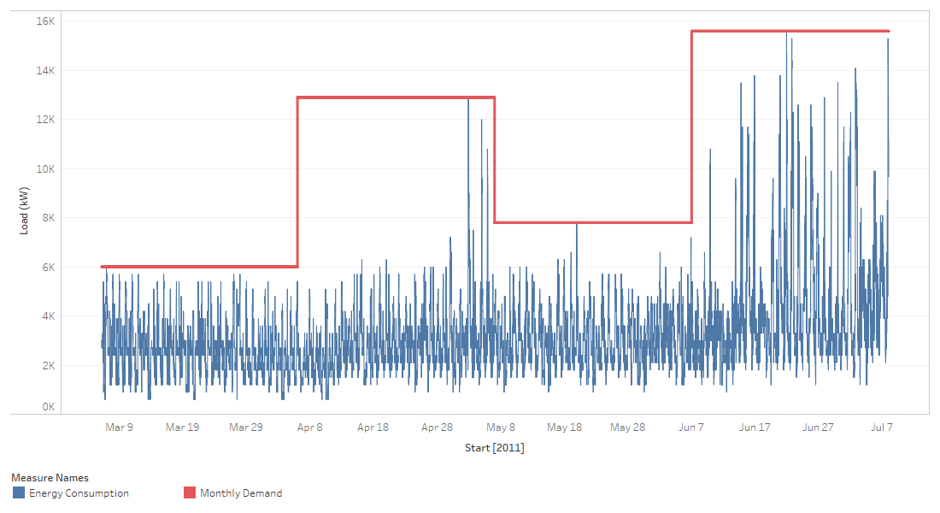

I am using a simplified rate schedule based on the PG&E A10S summer tariff:

* Part Peak (9:30am to 6:30pm) energy rate: $0.17425/kWh
* Off-Peak (all other times) energy rate: $0.14619/kWh
* Demand rate: $20.05/kW

Weekend and Peak rates are ignored, as are winter rates, for simplicity.

The monthly load data, along with forecast spend based on this simplified tariff schedule, is summarized below:

|  |  |  |  |  |  |
| --- | --- | --- | --- | --- | --- |
| Bill_start | Demand_kw | Energy_kwh | Spend_$ | Spend_demand_$ | Spend_energy_$ |
| 3/6/2011 | 6,000 | 1,887,000 | $445,934 | $120,300 | $325,634 |
| 4/6/2011 | 12,900 | 2,118,600 | $623,599 | $258,645 | $364,954 |
| 5/7/2011 | 7,800 | 2,279,550 | $550,932 | $156,390 | $394,542 |
| 6/7/2011 | 15,600 | 3,265,444 | $876,904 | $312,780 | $564,124 |
| 7/8/2011 | 16,200 | 3,293,756 | $881,752 | $324,810 | $556,942 |
| 8/8/2011 | 15,300 | 2,917,500 | $799,465 | $306,765 | $492,700 |
| 9/8/2011 | 15,300 | 2,773,163 | $775,683 | $306,765 | $468,918 |
| 10/9/2011 | 10,800 | 2,087,550 | $575,020 | $216,540 | $358,480 |
| 11/9/2011 | 6,900 | 2,075,550 | $492,501 | $138,345 | $354,156 |
| 12/10/2011 | 7,200 | 2,091,075 | $504,904 | $144,360 | $360,544 |
| 1/10/2012 | 6,900 | 2,063,625 | $493,260 | $138,345 | $354,915 |
| 2/10/2012 | 6,900 | 2,006,700 | $487,265 | $138,345 | $348,920 |
| 3/12/2012 | 6,300 | 1,423,275 | $375,349 | $126,315 | $249,034 |

# State Space:

The simplified state space, based loosely off of Lim’s implementation, includes:

* The time of day
* The state of charge of the battery
* The load

Additionally, I also consider the ‘current demand’, that is, the current peak observed in the month thus far. This is a knowable feature at any given time and provides the agent important insight into the past peak (allowing it to consider behavior that would avoid an increase in this value). The demand is initialized at 25% of the peak load each episode (for now).

To keep the state space small, I have limited the states to:

$S_{time of day}∈\{0:00 – 3:59, 4:00-7:59, 8:00-11:59, 12:00-15:59,$ $$16:00-19:59, 20:00-23:59\}$$

$S_{state of charge}∈\left\{0-3,300, 3,300-6,600, 6,600-10,000, 10,000\right\}$

$S_{load}∈\{300-2067, 2067-3833, 3833-5600, 5600-7367, 7367-9133,$ $$9133-10900, 10900-12,667, 12,667-14,433, 14,433-16,200\}$$

$S_{demand}∈\{4050-5400, 5400-6750, 6750-8100, 8100-9450,$ $$9450-10,800, 10,800-12,150, 12,150-13,500, 13,500-14,850, 14,850-16,200\}$$

|  |  |  |  |
| --- | --- | --- | --- |
| State | Number of Possibilities | Unit | Range |
| Time of day | 6 | Time | 4-hour windows across 24 hour day |
| State of Charge | 4 | kWh | 0-10,000kWh for a 10MWh useful range battery |
| Load | 10 | kW | 300-16,200 kW, based on full range of observed load |
| Demand | 10 | kW | 4,050-16,200kW based on 25%-100% of observed load |

Note that the actual variables are all basically continuous, and so the actual environment is ‘mapped’ to these state spaces based on the intervals given. This limits the total possible spaces to 2,400.

# Action Space:

The action space is similarly limited to just three possible actions: Discharge, wait, or charge. The discharge and charge rates are currently 2,000kw (where charging the battery adds load, and discharging reduced load). This is a gross approximation that limits the utility of the battery, but is sufficient for testing and setup.

$A ∈\{-2,000kW, 0kW, 2,000kW\}$

# Transition matrix:

One of the complications of the setup is that the next state *t+1* depends partly on the action selected by the agent, since this action may impact the state of charge and the demand, and partly on the environment, which includes the load at the next time step and the time of day at the next time step. This is not so important if we move to a model-free approach, but makes it more challenging to develop a complete set of transition probabilities.

I did implement a simple peak-shaving algorithm, where the agent tries to discharge whenever the load is above a set demand threshold, and charges in the morning. This policy is referred to as $π_{naive}$. The following shows the behavior of this (not very good) policy on overall demand. The original load is shown by the blue line, with the demand shown by the horizontal red line. The net load on the grid, after the battery action, is shown by the shaded orange area, and the new demand shown as the horizontal orange line.

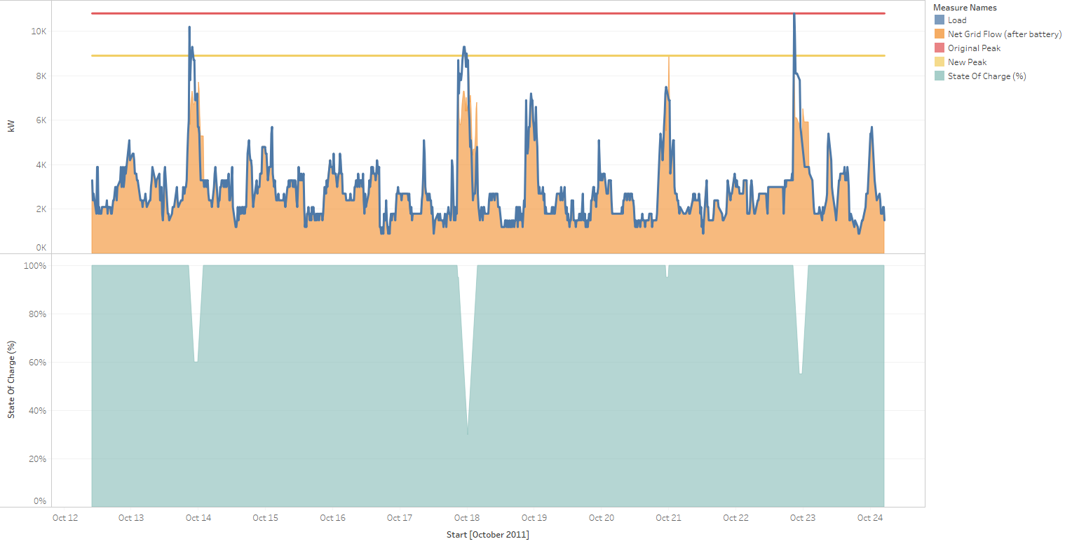

This gives us a full set of state-spaces for each of the 13 sample episodes (billing periods), and I built transition probabilities up from that, for each possible action at each state *S* encountered in the episode following this policy $π_{naive}$. To do so, I looked at the ‘after-state’ – the state that you would be in at time *t+1* if you took action A, and kept track of the frequency in which you transition from that state to the after-state taking that action. Normalizing the frequency of transitions from each state *S* to *S’* by the total number of transitions from *S* gives the probability of transitioning from S to S’ taking action A, $p\left(S^{'} | S,a\right),$ following policy $π_{naive}$.

However, the state spaces (particularly demand and state of charge) are limited to those that the agent will end up in following this naïve policy, and we therefore do not get a good or complete transition matrix. I think it is too sparse to be useful. As you can see in the Excel file attached, in particular, the agent very rarely ends up in a depleted state of charge. In fact, with this approach and over the 13 sample episodes, we only end up in 547 of the 2400 states (and thus have transition probabilities from only those 547 states).

An open question is how we want to handle this – one option would be to have an agent take random actions at all time steps and run it 10,000 times or something. This is for discussion.